 Pangani Basin Water Board 
Hydrological Bulletin Jan 2026
2025

RUVU CATCHMENT
RAINFALL TRENDS
Generally, rainfall in the basin is bimodal. Rainfalls are categorized in two periods; long rains occurring in March-June and short rains October –December. Rainfall patterns are largely controlled by altitude; the highlands receive more rains about 1000-2000mm per annum while the lowlands receive rains between 500-600mm per annum.
In January 2026 the rainfall distribution in Ruvu catchment were not even as observed in 6 meteorological stations.The maximum rainfall observed was 14.5mm, minimum rainfall was 0mm and average rainfall 0.73mm as analyised in 6 stations. The figures below shows Basin percentage area of rainfall and rainfall distribution in Ruvu catchment.

RIVER FLOWS
The Pangani Basin has two main headwater rivers feeding the large reservoir Nyumba ya Mungu Reservoir, the Kikuletwa River and Ruvu River. The Ruvu supplying water to Nyumba ya Mungu effectively forms part of the upstream of the main Pangani River (after the dam). The source of (this) Ruvu in the Pangani system is from Lake Jipe and surrounding catchments (including areas influenced by northern slopes of mountains like Mount Kilimanjaro).
Ruvu via Lake Jipe and its catchment is critical source for the Pangani Basin’s water supply, hydropower, irrigation and downstream flow. The average flow of Ruvu river at Kifaru is month of January 2026 was 4.71 m3/s. This flow contributed by upstream rainfall surrounding Mount Kilimanjaro and its below than 1.2m3/sec compared with average rainfall in January 2025. The figures below show flow distribution measured at Ruvu river at Kifaru gauging station and hydrographs of monitoring stations.

WATER LEVEL IN DAMS
Nyumba ya Mungu
The reservoir has an area of 140 square kilometers and 1.1 Billion cubic meters storage capacity. It is a regulating body for various water uses including irrigation agriculture, livestock, wildlife, navigation and three (3) hydropower plants at Nyumba ya Mungu (8MW), Hale (21MW) and New Pangani Falls (68MW).
Generally, the trend of water levels is due to the high quantity of the long rains (Masika) started mid of March and lower quantity of short rains period (October to December) as confirmed by Tanzania Meteorological Authority (TMA). The average water level (WL) of NYM Dam in this month of January was 687.84 m.a.s.l
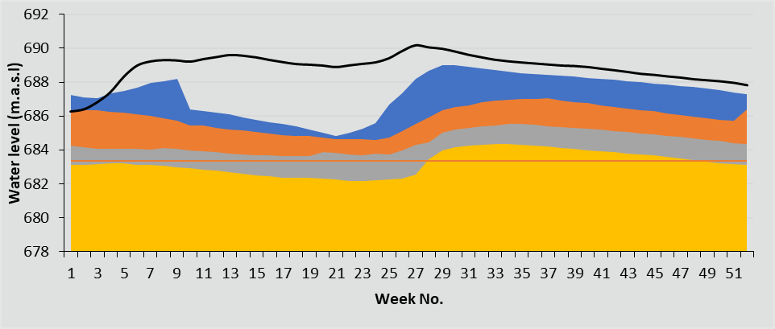

CONCLUSION
The Ruvu Catchment experience partial distribution of rainfall in this month of January.The river flows in Ruvu river as well as water levels of Lake Jipe and Nyumba ya Mungu are expected to be higher than their monthly average in the coming rainfall season.
Therefore, Management of Pangani Basin Water Board emphasizes on effective and efficient use of available water for sustainable water resources management

